IT SUPPORT PORTFOLIO

Project 002
Network Troubleshooting
IP configuration • Connectivity testing • DNS • Route tracing

Project details | Information
Device used | TM1 laptop
Operating environment | Windows Command Prompt
Project type | Personal hands-on networking lab
Destination used | Google public DNS (8.8.8.8) and google.com
Status | All practical exercises completed; observations documented

This is a truthful record of personal practice, not paid employment or client work.

1. Project overview
This lab practised basic Windows network-diagnostic commands to understand a laptop's network configuration, test local and external connectivity, investigate DNS resolution, and trace the route to a public destination.

Objectives
- Read the laptop's IP address, subnet mask and default gateway.
- Test communication with the local gateway and a public IP address.
- Use nslookup to investigate domain-name resolution and compare DNS servers.
- Use tracert to observe the route to a public destination.
- Use ping with a hostname to test name resolution and connectivity together.
- Record evidence and explain findings without assuming that every timeout indicates a fault.

2. IP configuration – ipconfig
Command used:
ipconfig
Field | Observed value | Meaning
IPv4 address | 172.20.10.2 | Private address assigned to the laptop on its current network.
Subnet mask | 255.255.255.240 | Defines the local IPv4 network range.
Default gateway | 172.20.10.1 | Gateway the laptop uses to reach other networks.
Link-local IPv6 | fe80::… | IPv6 address used on the local network link.
Other adapters | Media disconnected | Ethernet and virtual/local adapters shown were not connected.

Finding: The Wi-Fi adapter had an IPv4 address and a default gateway. This indicates that the laptop had network configuration assigned, but it does not alone prove internet access.

3. Local gateway connectivity – ping
Command used: ping 172.20.10.1
Measurement | Observed result
Packets sent | 4
Packets received | 4
Packets lost | 0 (0%)
Minimum round-trip time | 25 ms
Maximum round-trip time | 30 ms
Average round-trip time | 28 ms

Finding: All four probes received replies from the default gateway. The laptop could communicate with its local gateway during this test.

4. Public IP connectivity – ping
Command used: ping 8.8.8.8
Measurement | Observed result
Packets sent | 4
Packets received | 4
Packets lost | 0 (0%)
Minimum round-trip time | 32 ms
Maximum round-trip time | 136 ms
Average round-trip time | 59 ms

Finding: The laptop received replies from Google's public DNS IP address. This demonstrates connectivity beyond the local gateway at the time of testing. The first reply was slower than the next three.

5. DNS investigation – nslookup
First command: nslookup google.com
Output | Observation
DNS server name | Unknown
DNS server address | fe80::f887:f1ff:fe71:4664 (IPv6 link-local address)
Initial result | DNS request timed out after 2 seconds
Final result | google.com resolved to an IPv6 address: 2a00:1450:4006:816::200e

Finding: The initial DNS request timed out, but the lookup subsequently returned an address for google.com. Therefore, this result does not show a complete DNS failure. The displayed server name 'Unknown' means Windows did not identify a hostname for that DNS server; it does not by itself prove that the server is faulty.

6. Direct DNS comparison
Command used: nslookup google.com 8.8.8.8
Output | Observed result
DNS server name | dns.google
DNS server address | 8.8.8.8
IPv4 address returned | 142.251.208.238
IPv6 address returned | 2a00:1450:4006:820::200e
Response | Non-authoritative answer; lookup completed without a displayed timeout.

Finding: A direct query to Google's public DNS server successfully resolved google.com. This provides a useful comparison with the initial lookup, which had a timeout before returning an answer. The cause of the initial timeout was not established.

7. Route investigation – tracert
Command used: tracert 8.8.8.8
The trace completed and reached dns.google [8.8.8.8] at hop 14. The first hop was the default gateway, 172.20.10.1. The trace displayed some non-responsive probes (asterisks) at hops 2, 4 and 7, while later hops responded and the destination was reached.
Hop | Address / result | Interpretation
1 | 172.20.10.1 | Default gateway responded.
2 | Request timed out | No response to the three probes at this hop; not proof of a broken route.
3 | 10.197.35.1 | Responded.
4 | 172.27.21.13 | One of the three probes responded.
5–6 | 172.27.21.1; 172.23.21.12 | Responded.
7 | 41.207.252.234 | Some probes did not receive a response.
8–13 | Intermediate addresses responded | Traffic continued through the route.
14 | dns.google [8.8.8.8] | Destination reached; trace complete.

Finding: The destination was reached. Some intermediate devices did not respond to every traceroute probe. Routers may filter or deprioritize diagnostic probes, so isolated asterisks should not automatically be diagnosed as an outage.

8. Hostname connectivity – ping google.com
Command used: ping google.com
Measurement | Observed result
Resolved IPv4 address | 142.251.208.238
Packets sent | 4
Packets received | 4
Packets lost | 0 (0%)
Minimum response | 175 ms
Maximum response | 185 ms
Average response | 178 ms

Finding: The laptop resolved google.com to an IPv4 address and received all four ping replies. This combines a hostname lookup with a connectivity test. The average response time was higher than in the earlier ping to 8.8.8.8; one short test is not enough to conclude that the connection is consistently slow.

9. Overall assessment
The tests demonstrate that, during this lab, the laptop had an assigned Wi-Fi IPv4 configuration, could reach its default gateway, could reach a public IP address, could resolve google.com using DNS, and could trace a route to 8.8.8.8. The direct Google DNS query completed successfully. The initial default-DNS lookup showed a two-second timeout before eventually returning an answer. The traceroute also showed some intermediate probes timing out, but the final destination was reached.
No confirmed network outage was identified in these tests. The cause of the initial DNS timeout was not determined. The varying response times are snapshots and should be retested over time before diagnosing persistent latency.

10. Skills demonstrated
- Using Windows Command Prompt for basic network diagnostics.
- Reading IPv4 configuration, subnet masks and default gateways.
- Testing local and public connectivity with ping.
- Investigating DNS resolution with nslookup.
- Specifying an alternate DNS server for comparison.
- Tracing network routes with tracert and interpreting non-responses cautiously.
- Recording test results and distinguishing observed facts from possible explanations.

11. Portfolio-ready case-study summary
Completed a personal Windows network-troubleshooting lab using ipconfig, ping, nslookup and tracert. Identified the laptop's Wi-Fi IPv4 address (172.20.10.2), subnet mask (255.255.255.240) and default gateway (172.20.10.1). Confirmed gateway and public-IP connectivity with 0% packet loss in four-packet tests. Investigated DNS: the default lookup timed out initially but later resolved google.com; a direct query to Google's DNS server (8.8.8.8) returned IPv4 and IPv6 addresses. Traced the route to 8.8.8.8, reaching the destination at hop 14 despite some intermediate probes not responding. A final ping to google.com resolved the hostname and received four replies with 0% packet loss. No outage was confirmed; the initial DNS timeout and variable latency were documented for cautious interpretation. This was a personal practice lab, not paid client work.

12. Evidence screenshots
The following screenshots were supplied during the practical exercises. They provide visual evidence of the commands and results recorded in this report.
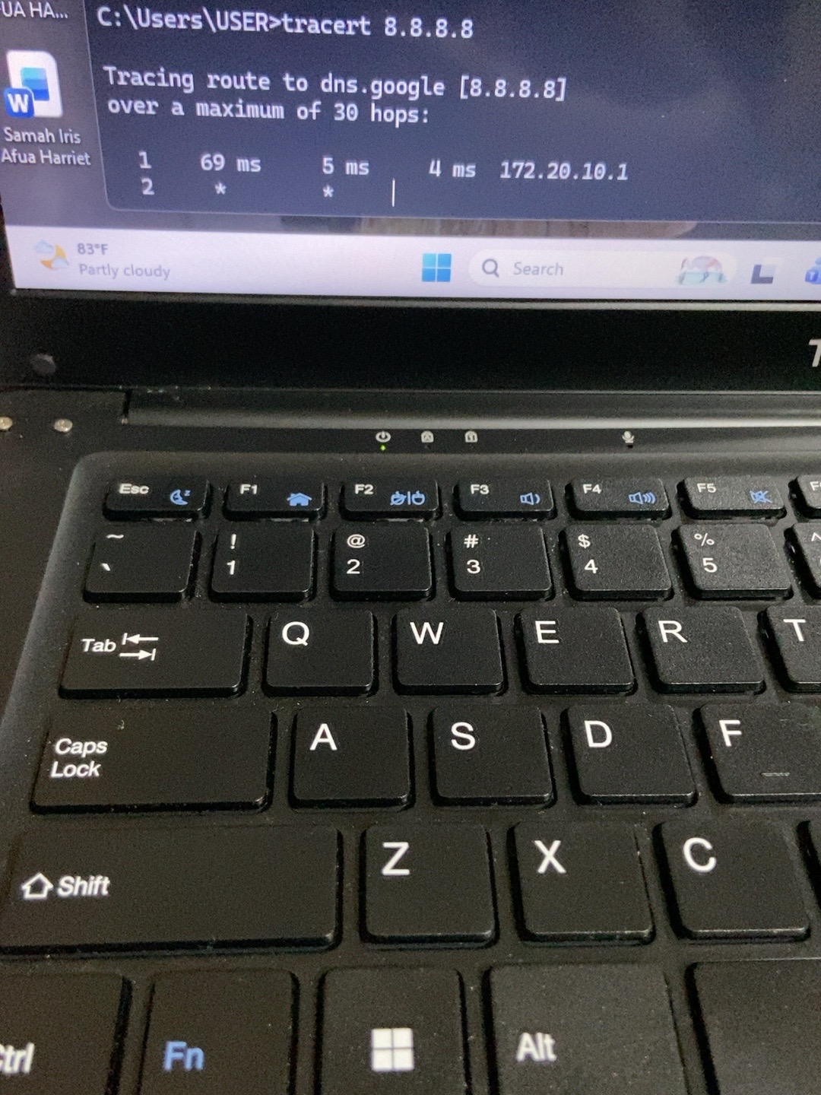
Evidence 1 – ipconfig output showing the Wi-Fi IPv4 address, subnet mask and default gateway.
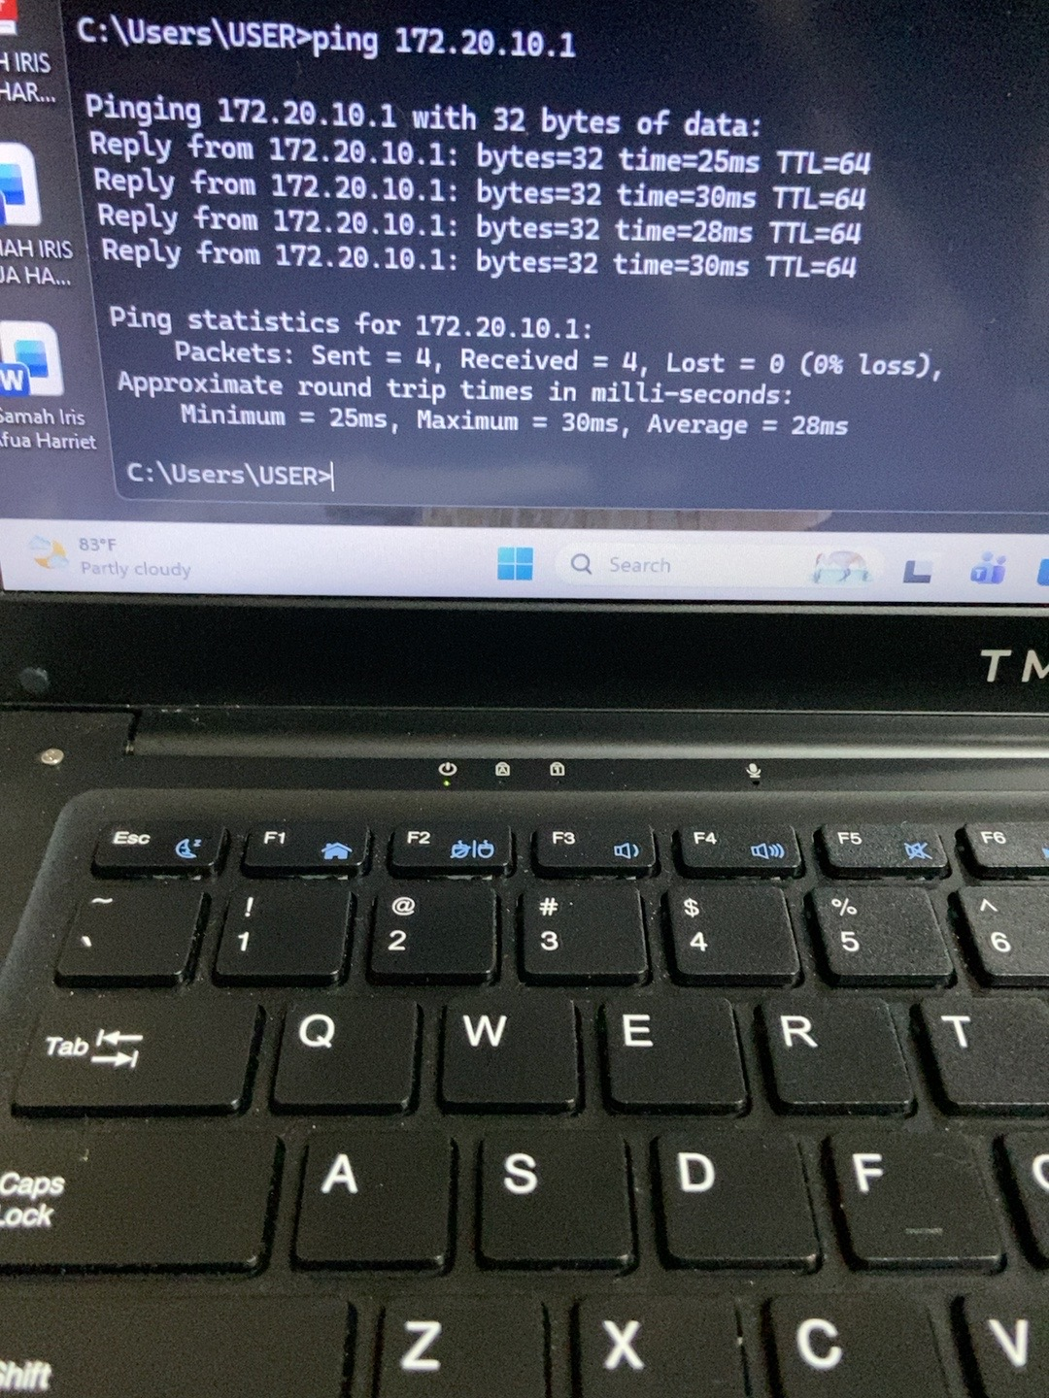
Evidence 2 – Gateway ping test (172.20.10.1), with four replies and 0% packet loss.
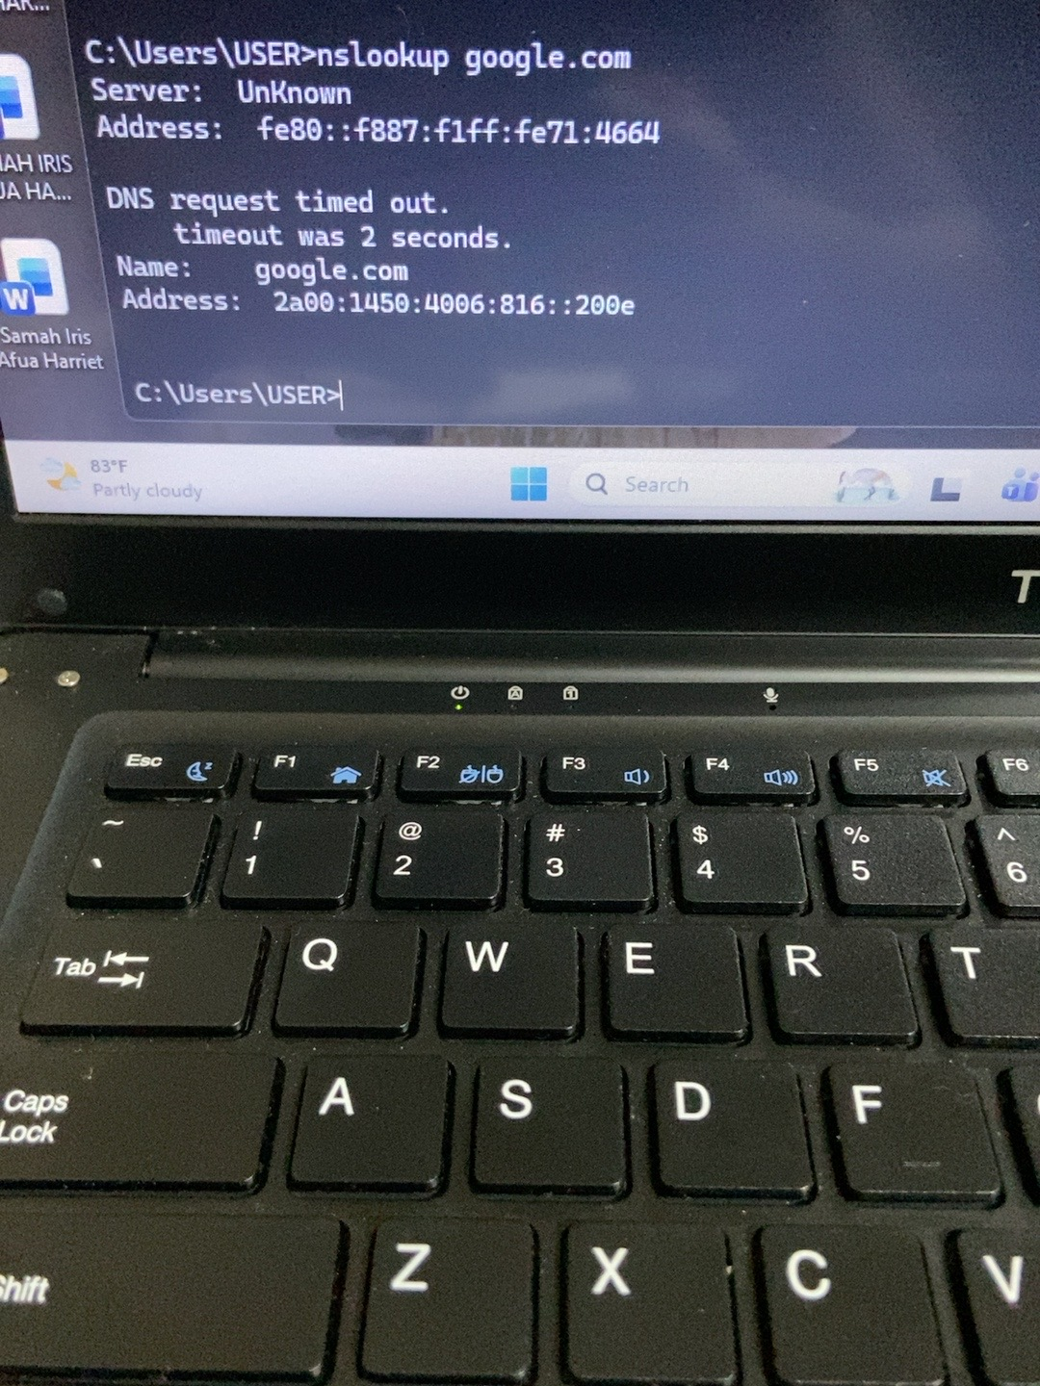
Evidence 3 – Public IP ping test (8.8.8.8).
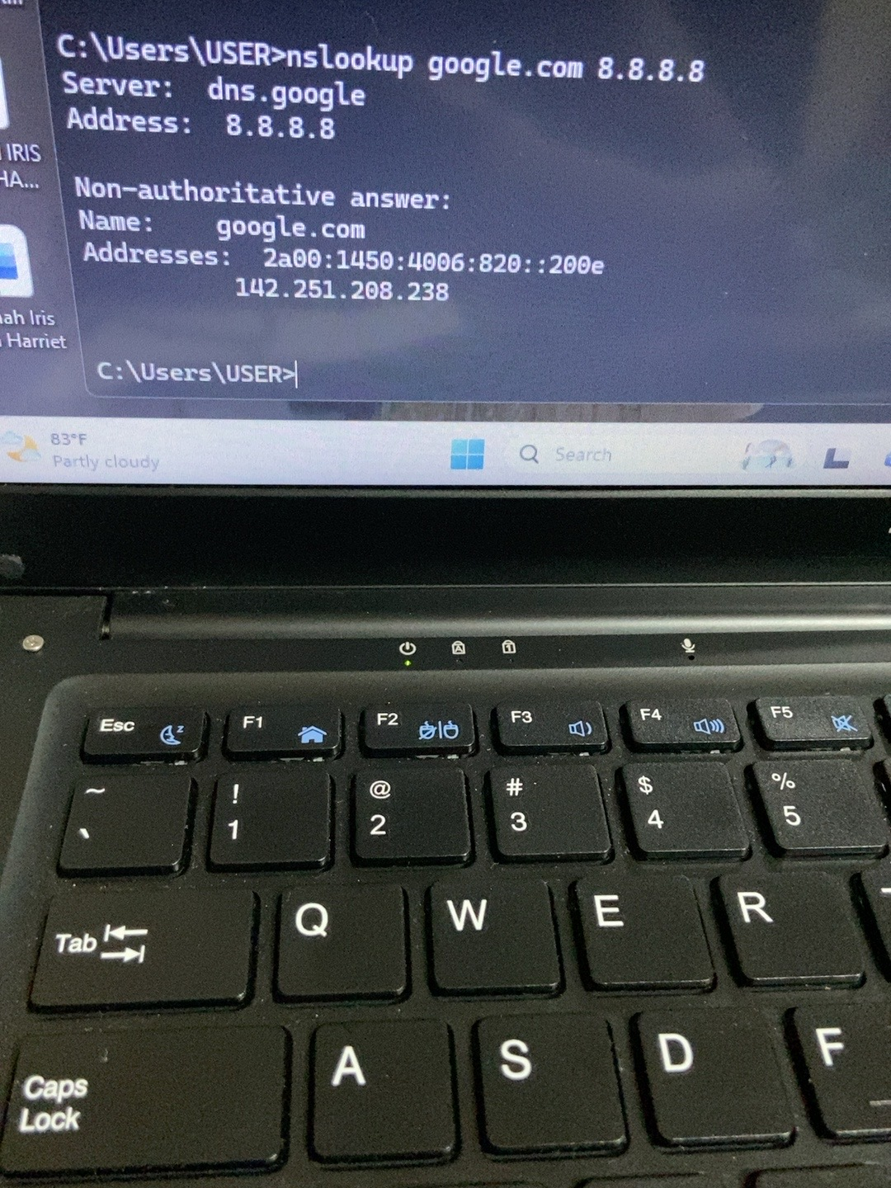
Evidence 4 – Initial nslookup test for google.com.
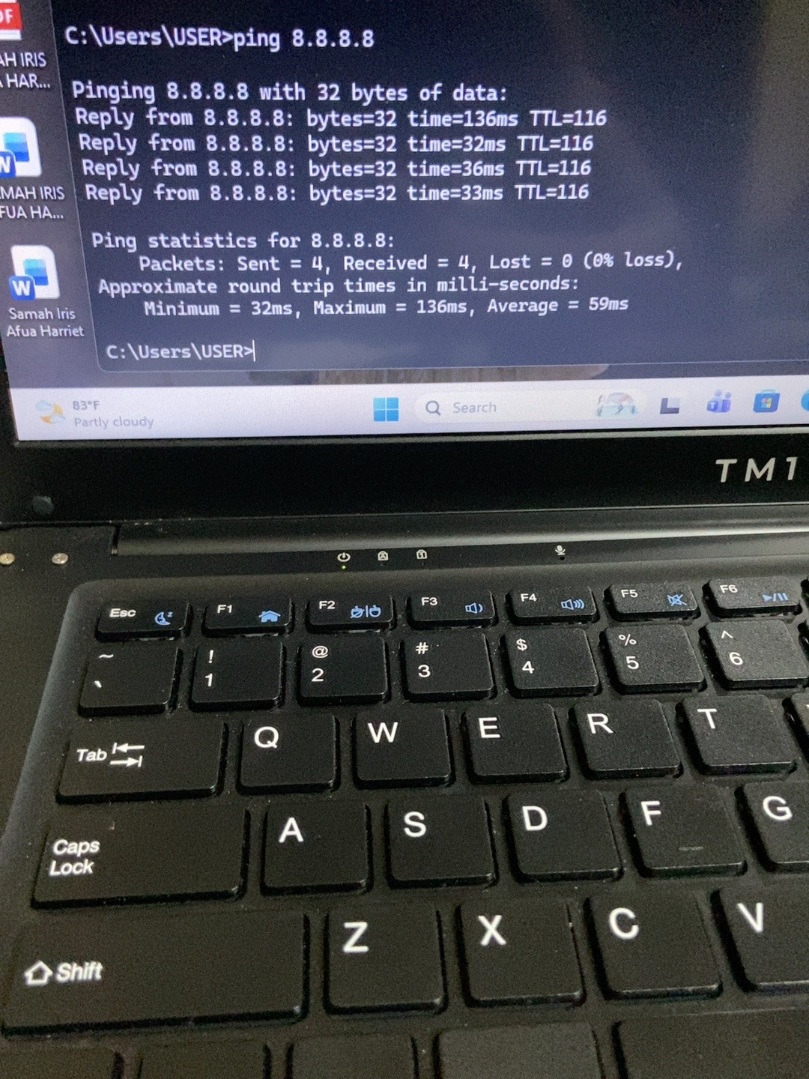
Evidence 5 – Direct DNS query to 8.8.8.8.
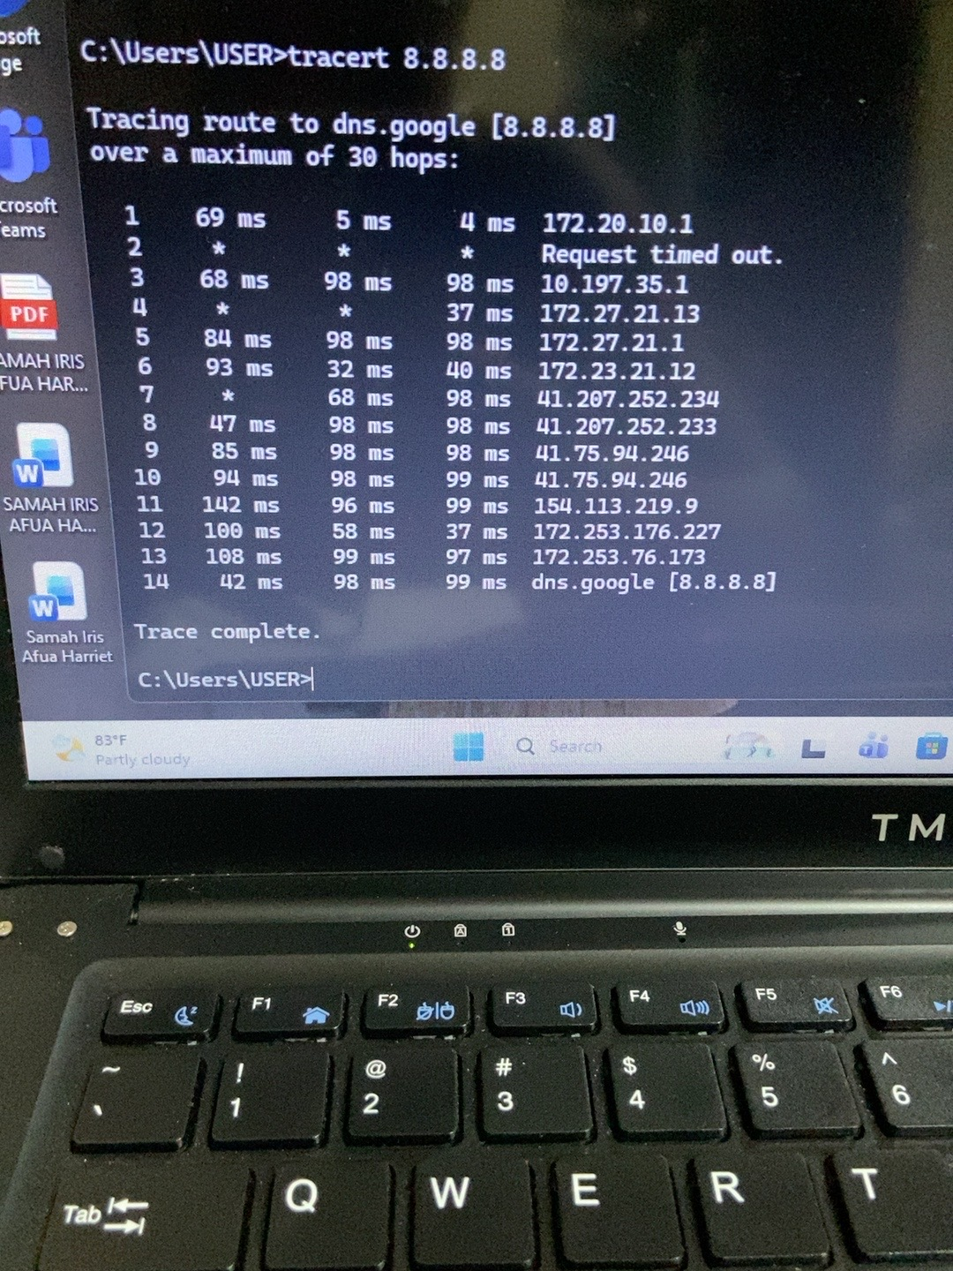
Evidence 6 – Completed tracert to 8.8.8.8, reaching the destination at hop 14.
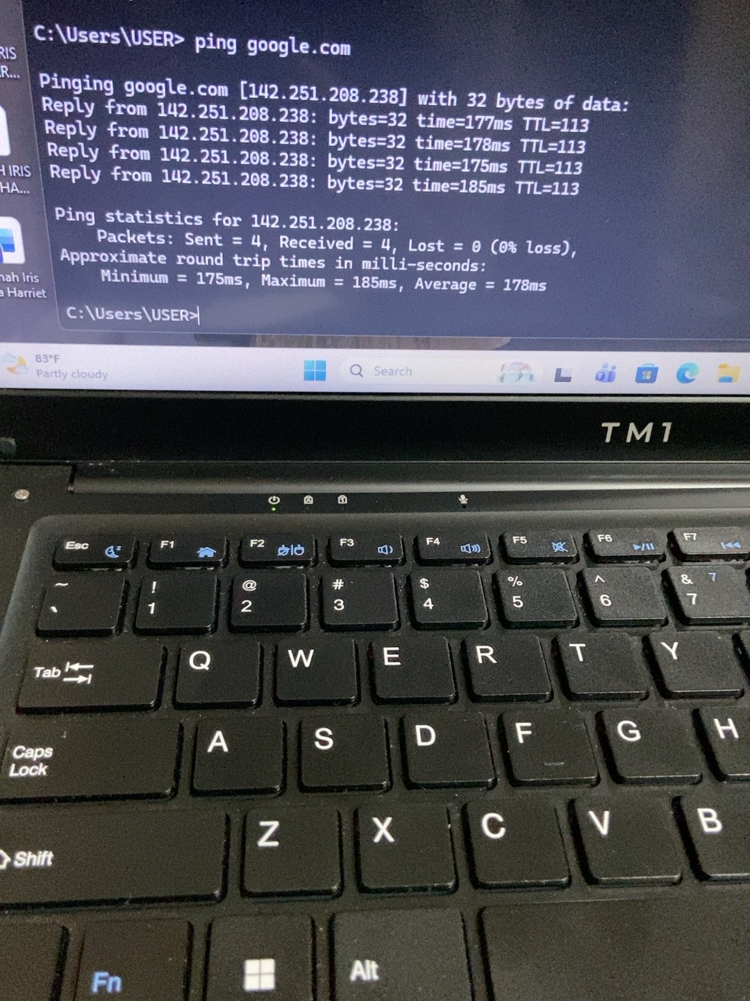
Evidence 7 – Final ping google.com test, with four replies and 0% packet loss.

13. Follow-up notes
If the laptop later experiences slow browsing or loss of internet access, repeat the relevant tests and record the date, network being used, command, result and time. Compare repeated results before changing DNS or other network settings.
Date / time | Network / context | Command and result | Follow-up action
____________ | ________________ | ________________________ | _____________________
____________ | ________________ | ________________________ | _____________________

